Create a react app for Student Management Portal named StudentApp and create a component named Home which will display the Message “Welcome to the Home page of Student Management Portal”. Create another component named About and display the Message “Welcome to the About page of the Student Management Portal”. Create a third component named Contact and display the Message “Welcome to the Contact page of the Student Management Portal”. Call all the three components.

1. Create a React project named “StudentApp” type the following command in terminal of Visual studio:
2. Create a new folder under Src folder with the name “Components”. Add a new file named “Home.js”
3. Home.js

import React,{Component} from 'react';

 class Home extends Component{

    render(){

        return(

        <div>

        <h3>Welcome to the Home Page of Student Management Portal</h3>

        </div>

        );

    }

}

export default Home;

1. Under Src folder add another file named “About.js”

About.js

import React,{Component} from 'react';

 class About extends Component{

    render(){

        return(

        <div>

        <h3>Welcome to the About Page of the Student Management Portal</h3>

        </div>

        );

    }

}

export default About;

5 . Under Src folder add another file named “Contact.js”

import React,{Component} from 'react';

class Contact extends Component{

    render(){

        return(

        <div>

        <h3>Welcome to the Contact Page of the Student Management Portal</h3>

        </div>

        );

    }

}

export default Contact;

1. Edit the App.js to invoke the Home, About and Contact component

import './App.css';

import Home from'./Components/Home';

import About from'./Components/About';

import Contact from'./Components/Contact';

function App()

{

return(

<div className="container">

<Home/>

<About/>

<Contact/>

</div>

);

}

export default App;

1. Execution of the code

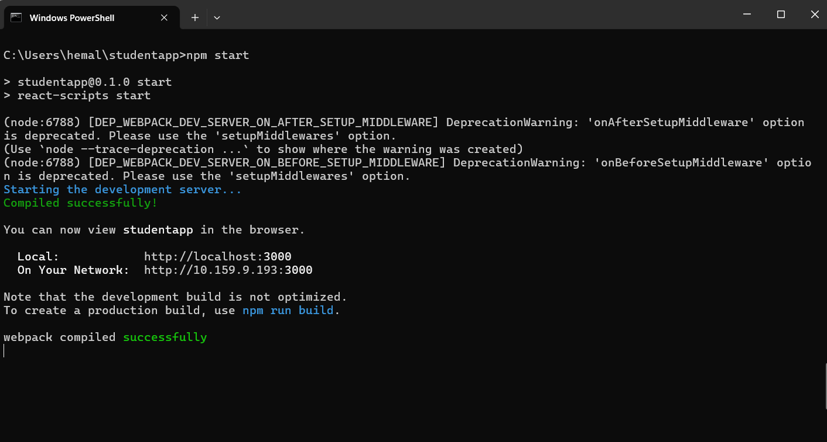

1. Open browser and type “localhost:3000” in the address bar: